Buenos Aires UBF 2022 Summer Bible Conference Report
Rivers of Living Water by M Caleb Kuper
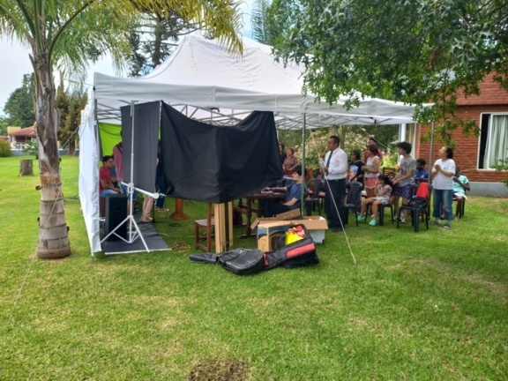
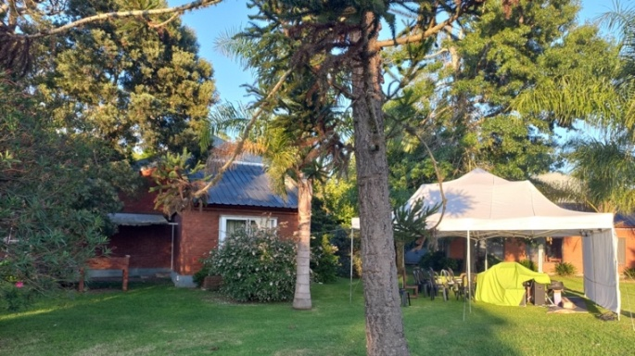
We celebrated our Summer Bible Conference from February 25 to March 1, 2022 in a beautiful place called Chascomús. It was a joint conference with Paternal UBF. M Ruth prayed with the sisters to make an environment while others prayed at home. After visiting several times, she found the most beautiful place by the lake. The only problem was that we needed to improvise because we couldn't use the dining room for our meetings. So God inspired us to rent a large tent for our meeting place. It was like the OT tabernacle. We prayed for over 40 participants but 53 attended: 43 in person and 7-10 people via Zoom. Through the conference two brothers and one sister were baptized by M Marcos in the pool: Sofía, Cristian, and Lucio (Victoria's brother). Praise God! Br. Mauro and Mirtha from Brazil, Mother of Mirtha from Paraguay, M Romina from USA and S. Pamela from Bolivia all participated via Zoom. All the messengers were well prepared with the word and their personal testimony since Mr. Marcos worked hard to help them.
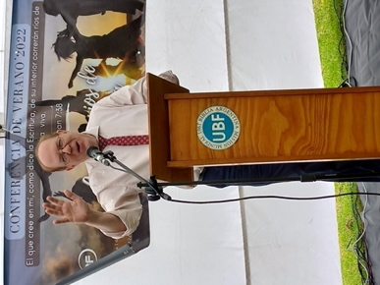
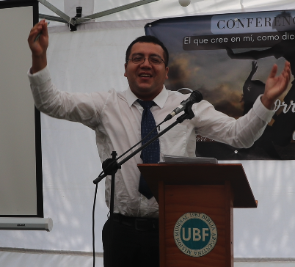
Through this conference we restored our faith, hope and love as well as our focus on eternity. M Caleb Kuper gave the opening message from Jn7:38, Rivers of Living Water, setting the theme for the conference. Throughout the conference we shouted, “Rivers of Living Water will flow!” We learned that the key to receiving living water is to “believe in Jesus” based on Jn7:38a: “Whoever believes in me…” M Caleb repented that he was still sad about M Hannah leaving but he began to believe in Jesus and experienced rivers of living water flowing within him. M Noah gave us a very powerful message from Jn5: Do You Want to Get Well? After seeing the man by the pool and learning that he had been like this for 38 years, Jesus asked him, "Do you want to be healed?" Jesus' question was intended to instill in him the desire and faith to receive healing from Jesus. Then Jesus commanded him to get up, pick up his mat and walk. Through his message we restored our faith and hope in Jesus who can heal us. M Erendira gave us the afternoon message from Is. 43, I Will Do a New Thing. Jesus made us a new creation as sons and daughters of God. Jesus opened the new way to have access to the Father God through his blood. Now we can call God: Abba, Father. Praise the Lord!
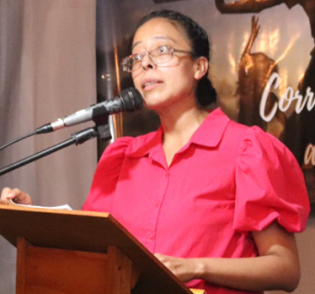
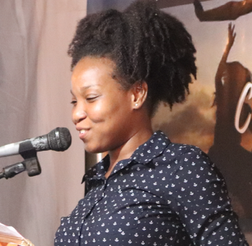
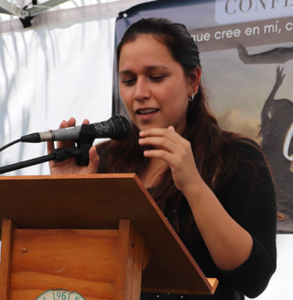
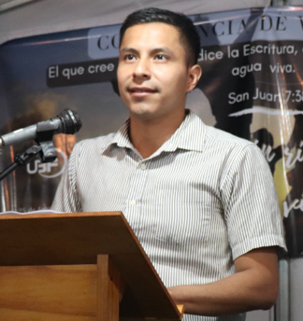
The next day we heard the second main lecture from Sisters Edeline and Victoria on Jn4, Living Water. This was a debut message for both of them. Edeline used to be a church hopper, but she made the decision to stay in UBF and grow up as a true worshipper. Victoria confessed her sins and found again that Jesus is her true husband. Through their joint message we were able to restore our first love in Jesus. The afternoon message was prepared by S. Alonso from Ezekiel 47, A River from the Temple. We learned that there is living water that flows from the temple of God in heaven. All who believe in Jesus can step into the rivers of living water of God's grace.
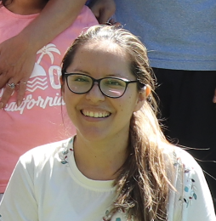
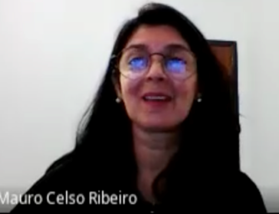
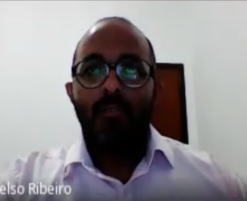
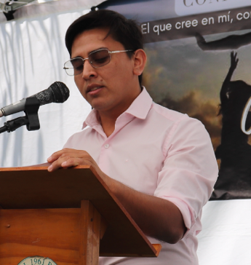
The next day we heard the third main lecture prepared by S. Nico from Luke 5: You Will be Fishers of Men. P.Nico formed a new family with S. Victoria. They have three children: Maia & Alma (from previous families), and new baby Thomas. S. Nico realized that he had dedicated himself a lot to his family and his work as a taxi driver. He repented and prayed to feed three new sheep and open his home for many sheep to come to rest. We all prayed to restore our hope to be fishers of men. The evening message prepared by Br. Mauro and S. Sandra was based on Acts 2:17, Young People Will See Visions. Brother Mauro was the Abraham from S. Paulo UBF (Brazil) but he had lost his calling and was living without a mission. But due to the push/prayers of S. Mirtha he returned to God. Now he wants to serve the evangelizing work in Rio de Janeiro. S. Sandra repented of criticizing others, which sometimes broke the spiritual vessel. She now has a better concept of the gospel of God’s grace that forgives others. She was too focused on taking up her cross and realized that she needed to focus on eternity. Her message touched everyone, and we could all repent being too focused on earthly struggles instead of eternity. The young and the old must have visions and dreams or they will perish. Through her message we were able to restore our hope in Jesus. Also, S. Mirtha served a mission field report on Brazil (Rio de Janeiro). We prayed for Paraguay as well.
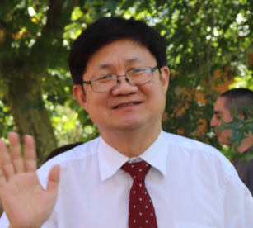
The closing message, Go and Make Disciples, was given by M Juan Moon, director of Paternal UBF. His message gave us a clear direction to go and make disciples on campus. First, we must go! Then make disciples. Jesus gave us the wonderful promise to be with us always until the end of the age so we can boldly go and make disciples of all nations with Jesus.
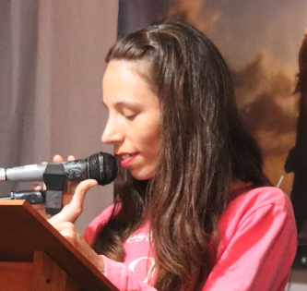
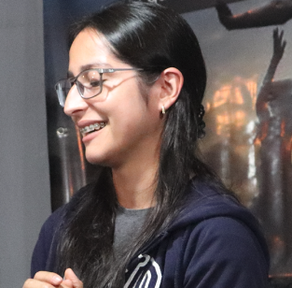
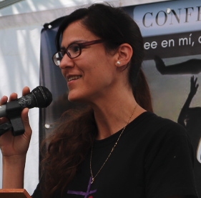
During the afternoons we listened to three life testimonies of Sister Sofia, Sister Vania and Sister Ximena. Sofia was fished by three sisters who have been fishing on campus: Sister Edeline, Victoria and Vania. She is a dance choreographer who led the dance team for the world mission night. Sofia has been steadily growing in God's word through Daily Bread and discipleship studies with Sister Vania. Sister Vania experienced a lot of pain and sadness growing up due to illness as a child and then her parents' divorce. But her mom found Jesus through a prayer warrior meeting, and then Sr. Vania began to believe. She prays to remain in Jesus the true Vine and be a fruitful branch. Sister Ximena is married to a Chinese gentleman named Alejandro. She shared that although they love each other, they fought a lot. But they are learning to forgive and love each other again. All of the testimonies were very graceful.
The music program was made up of José Moon and his new wife Sara Moon, S. Nico, S. Alonso, John Kuper, Jesús Alfredo, Victoria, Edeline and S. Sandra. Each song was well prepared as they practiced hard for two weeks. Our dance members were Jose, Sarah, P. Alonso, Sofia, John Kuper, S. Sandra, and Vania. The multifaceted dance with music from five countries was a prayer for Cuba, Trinidad and Tobago, Guinea-Equatorial, Jamaica and China. Many brothers and sisters were restored. We regained faith, hope and love in Jesus. Some returned from a time of absence such as Moni, Daniela, Jesús Alfredo, Iris and others. It was also a miracle that Bro. Cristian brought his family and he had a desire to be baptized. It was all the work of the Holy Spirit.
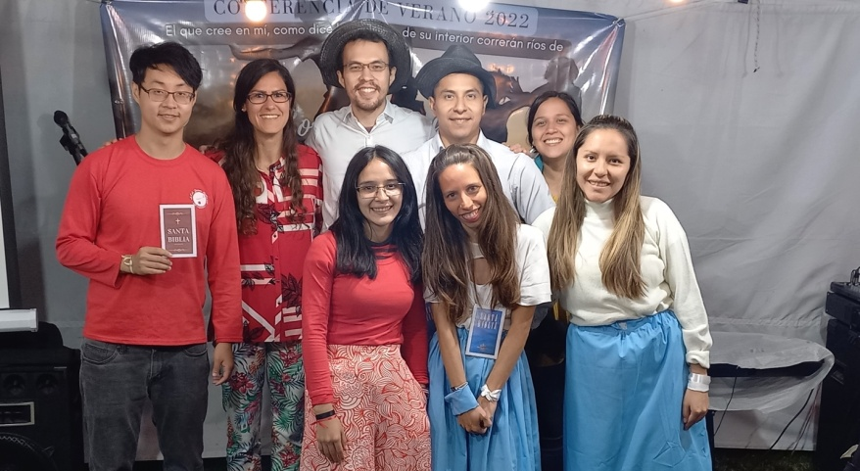
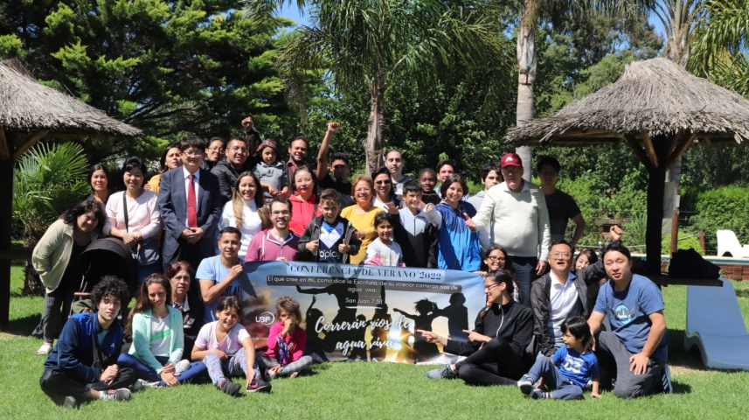
We returned to our mission field full of living water and clear direction to be fishers of men and to go and make disciples at UBA. May God bless the campus pioneering work in Argentina through fishing, one-to-one Bible study, and the formation of new house churches.

